|  |
| --- |
| Newchurch Village Community Association  newchurch-village.co.uk @NewchurchRoss  Charity number 1194179. Company number 12027719 |

# 

Defibrillators on play area and the little park in Newchurch

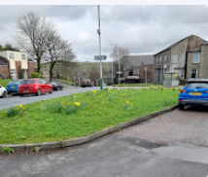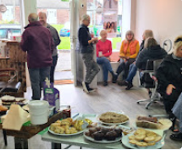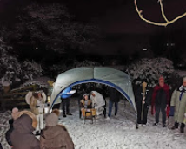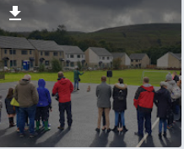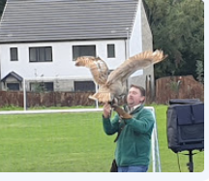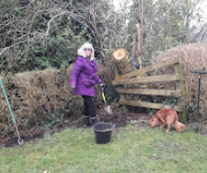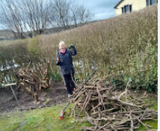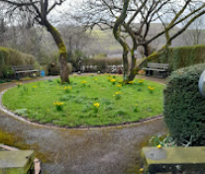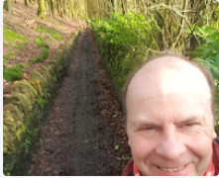

The Green which we are wanting to develop the new flower beds

Community and Charity Events – Bird of Prey, Walking Nativity and Macmillan Coffee Morning

Clearing paths and looking after local area